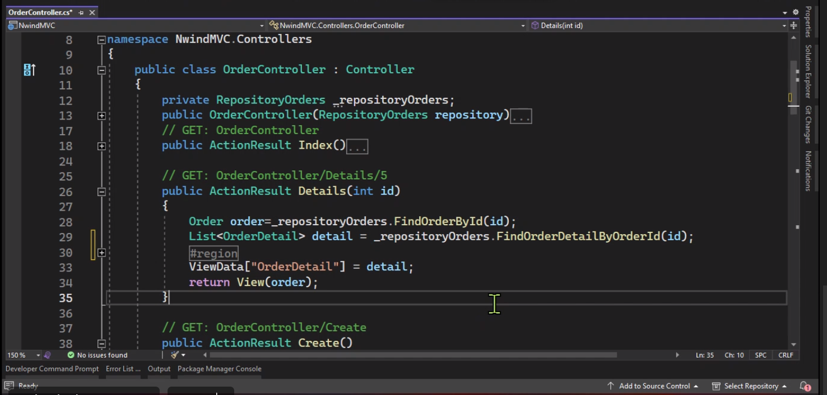

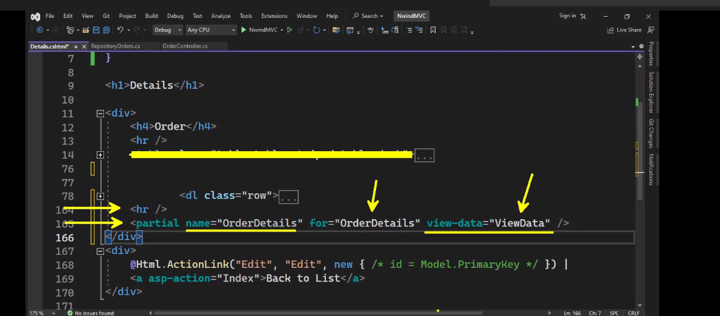

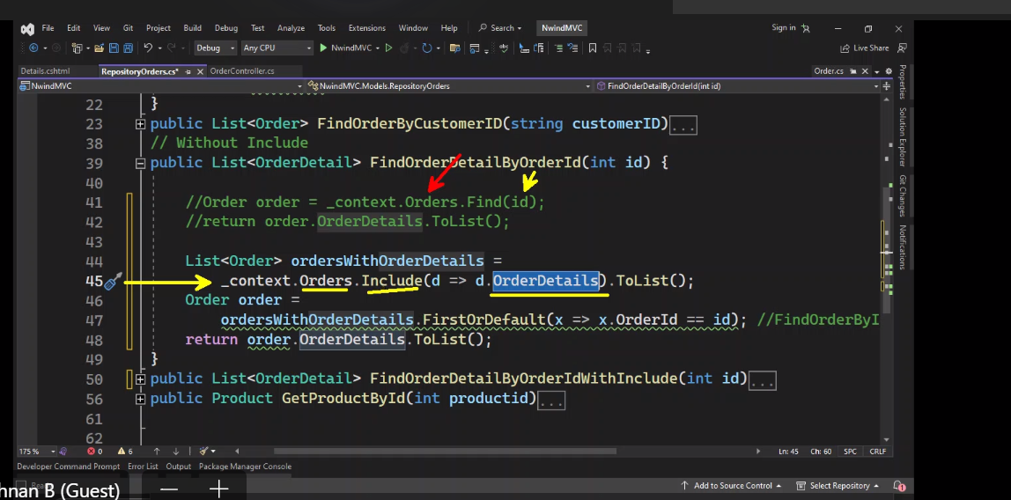

4

a

